Author | Cailen Matz | Approver(s) | Peter Langel, Jayson Fajardo

Revision Log:

REV | Revision Description  (Reason for Change) | Author | Rev. Date
1.0 | Initial Release | C.Matz | 2/24/2022
 |  |  | DRAFT 2-24

LABOR CODE:???
PURPOSE: This tool is part of a kit used at collision centers to lift the R1T body off the skateboard. Adapters attach at the gear tunnel hinge bolt locations.
GENERAL PRINCIPLES:
  - Follow safe vehicle lifting practices. Always check the stability of the vehicle before lifting.
  - Do not use the lift adapter for any vehicle other than R1T.
  - Do not perform lift alone, at minimum 1 spotter on the driver’s side and one on the passenger’s side required.
  - Check the lift adapters for any damage, cracks, etc. If the adapters are not in proper working order, discontinue use and get a new set.
TOOL BREAKDOWN:
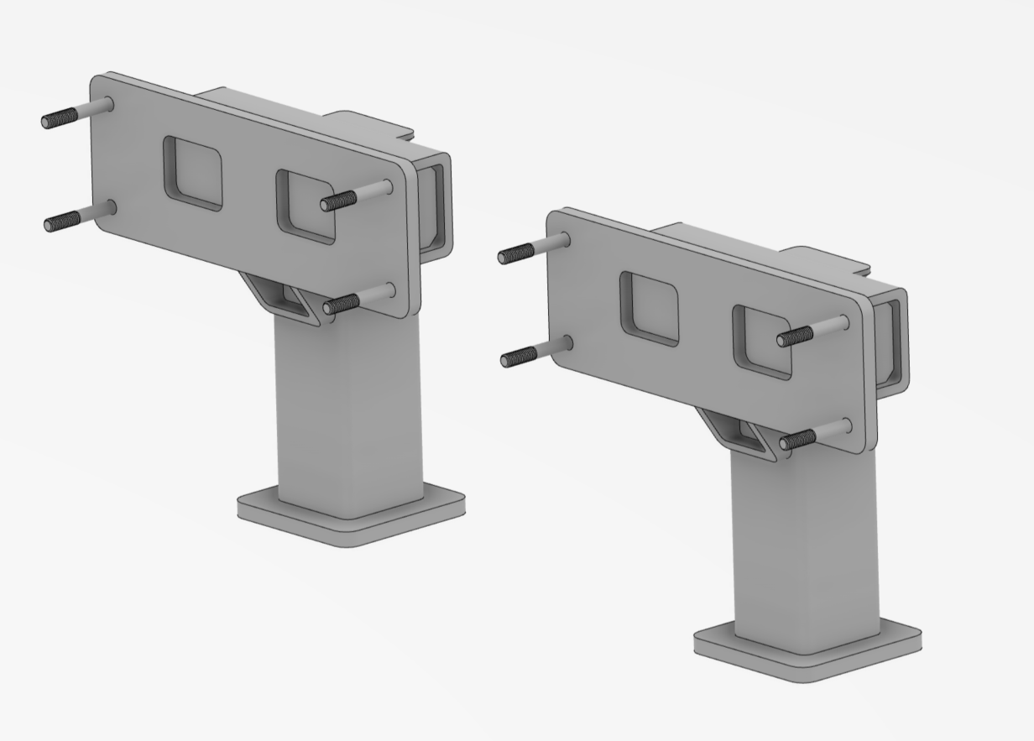
R1 RR ADAPTER (x2)
M8 x 1.25 Flange Screw (x8)
TOOL LOCATION: DRIVERS SIDE
DRAFT 2-24
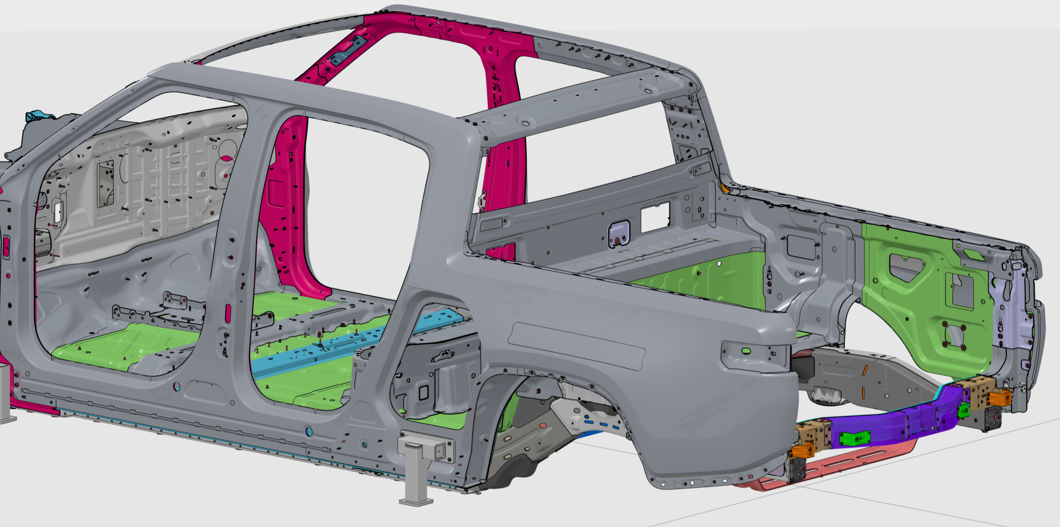
FWD

TOOL LOCATION: PASSENGERS SIDE
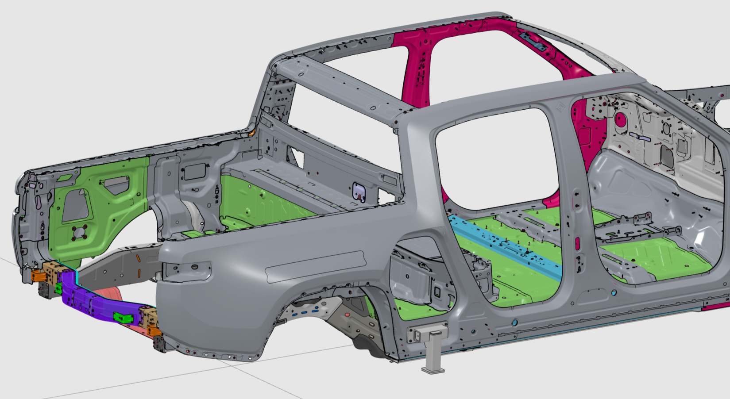
FWD

USING THE TOOL:
- Align adapter to gear tunnel hinge mount studs (4x) on the passenger’s side of the vehicle. Hand tighten M8 x 1.25 fasteners.
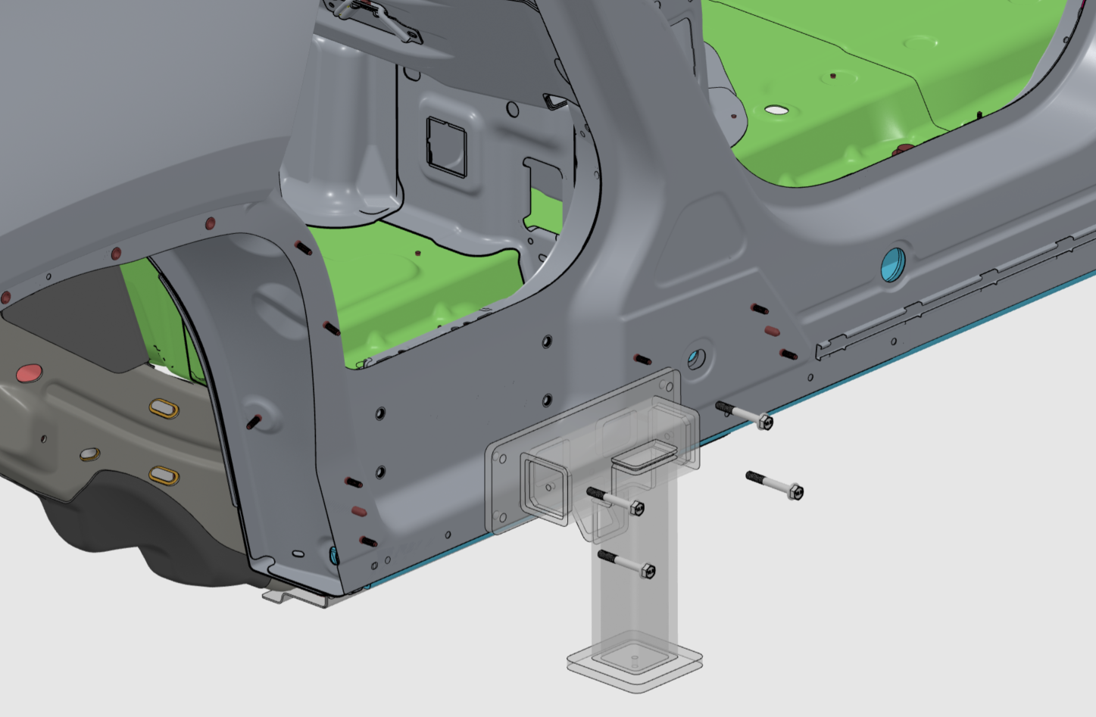
DRAFT 2-24
- Torque fasteners to 38 Nm
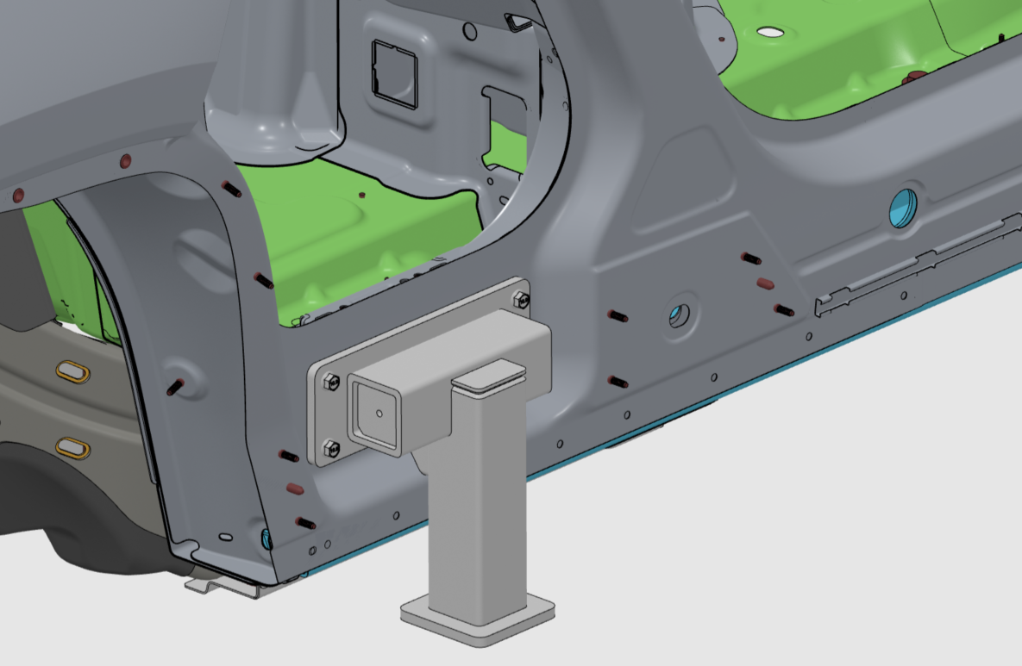
- Repeat steps 1 and 2 for driver’s side.
- Raise the lift and position just below the adapters. Adjust lift pad heights to ensure they contact both adapters simultaneously.

