Author | Cailen Matz | Approver(s) | Peter Langel, Jayson Fajardo
DRAFT 2-24
Revision Log:

REV | Revision Description  (Reason for Change) | Author | Rev. Date
1.0 | Initial Release | C.Matz | 2/24/2022

LABOR CODE:???
PURPOSE: This tool is part of a kit used at collision centers to lift the R1 body off the skateboard. Adapters attach at the front door lower hinge bolt locations.
GENERAL PRINCIPLES:
  - Follow safe vehicle lifting practices. Always check the stability of the vehicle before lifting.
  - Do not use the lift adapter for any vehicle other than R1.
  - Do not perform lift alone, at minimum 1 spotter on the driver’s side and one on the passenger’s side required.
  - Check the lift adapters for any damage, cracks, etc. If the adapters are not in proper working order, discontinue use and get a new set.
TOOL BREAKDOWN:
R1 FRT ADAPTER (x2)
M12 x 1.75 FLANGE SCREW (x4)

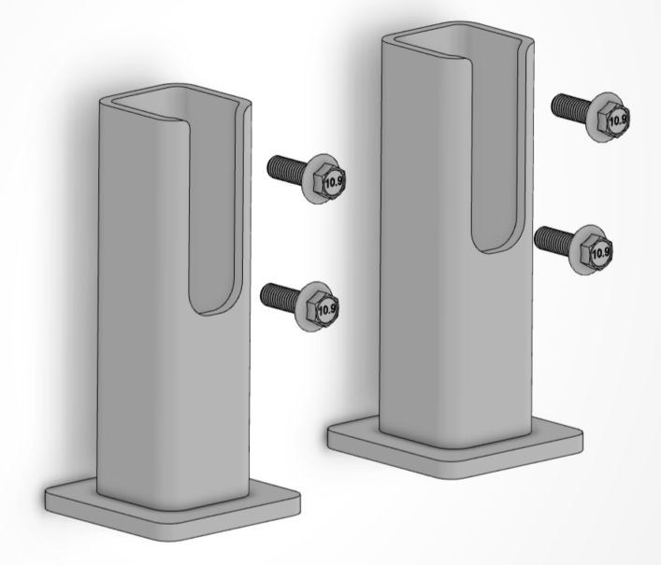
TOOL LOCATION: DRIVERS SIDE
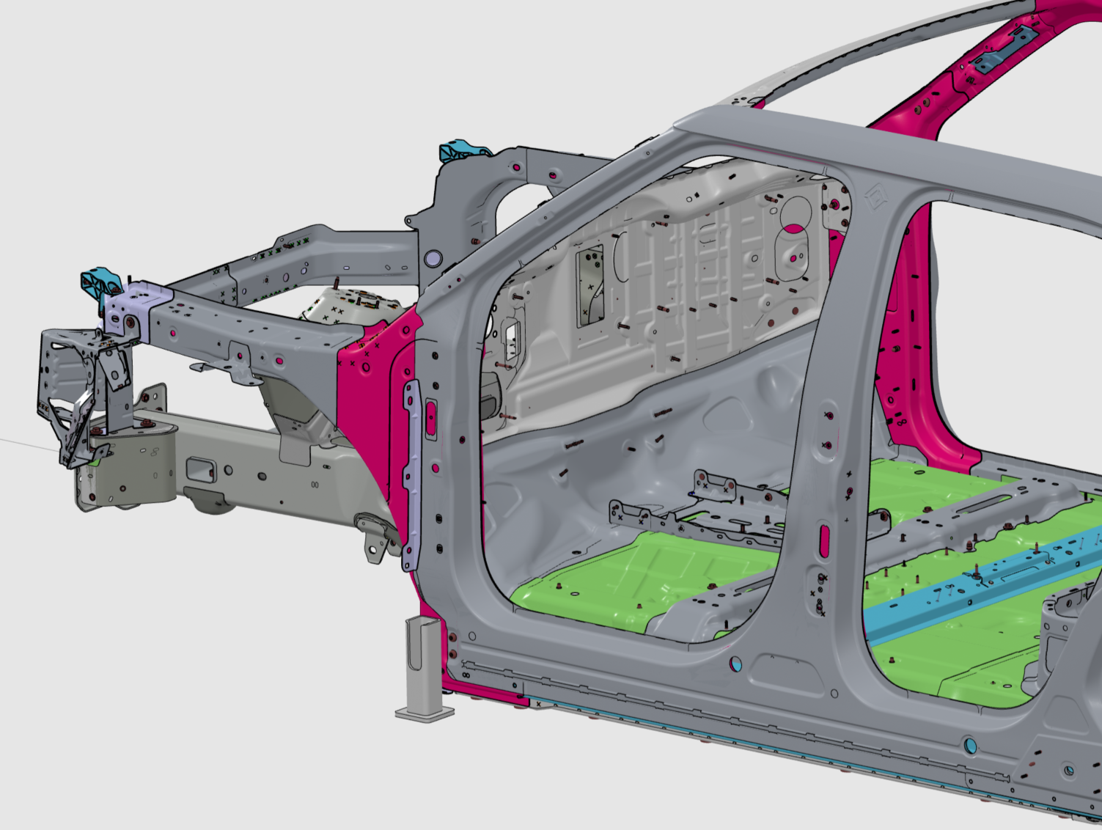
DRAFT 2-24
FWD

TOOL LOCATION: PASSENGERS SIDE
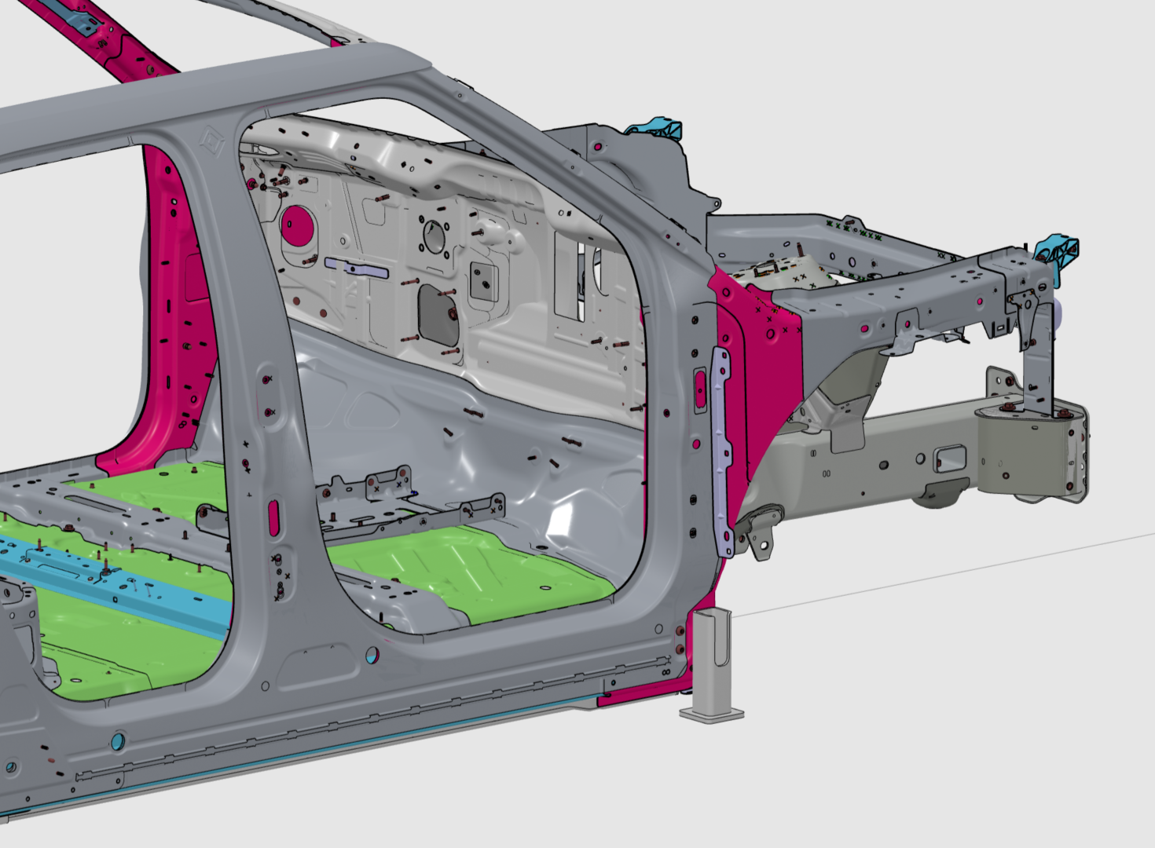
FWD
USING THE TOOL:
- Align adapter to weld nuts (2x) used to mount the tire block on the passenger’s side of the vehicle. Hand tighten M12 x 1.75 fasteners.
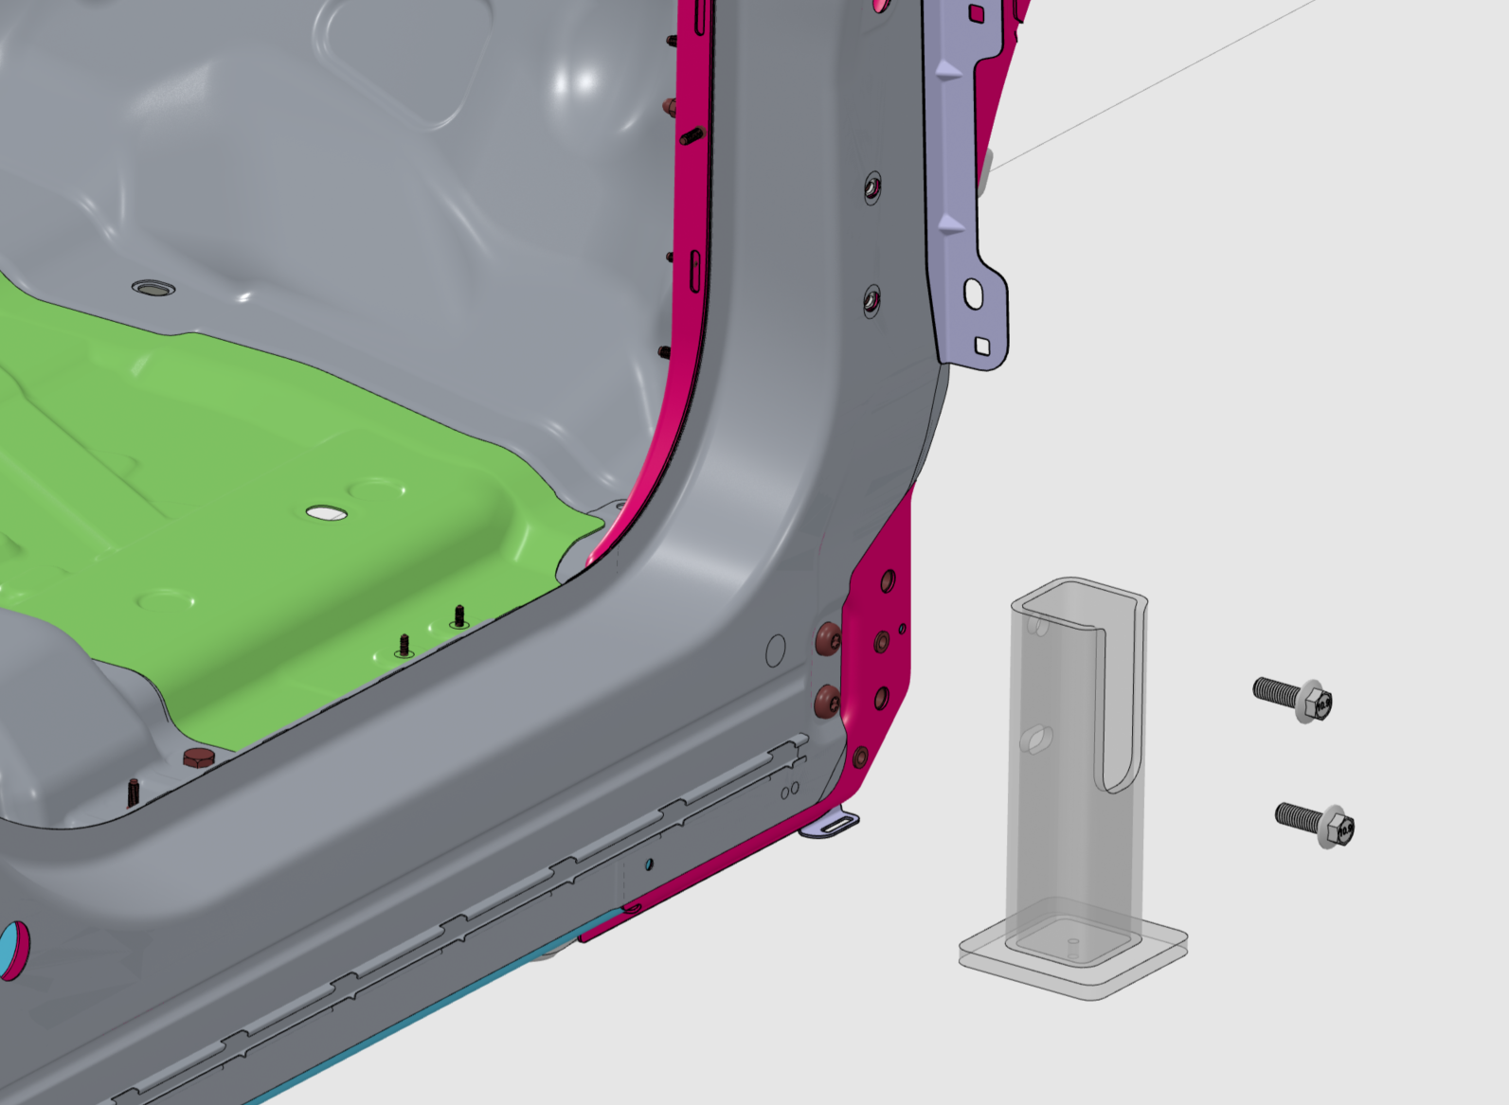
DRAFT 2-24
- Ensure base of adapter is parallel to the ground before torquing fasteners to 100 Nm
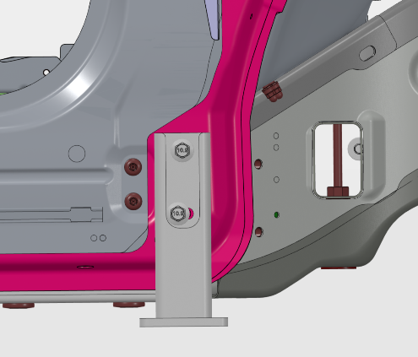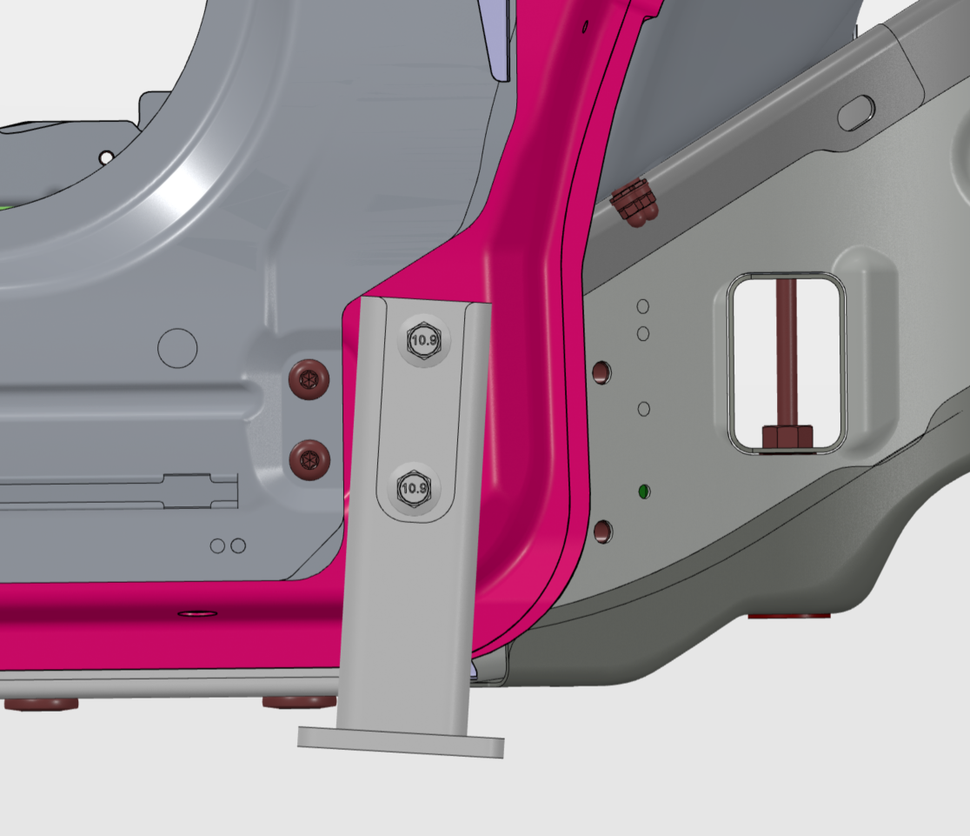

- Repeat steps 1 and 2 for driver’s side.
- Raise the lift and position just below the adapters. Adjust lift pad heights to ensure they contact both adapters simultaneously.
NOTE: Front lift adapters are common for multiple R1 vehicle programs, but rear lift adapters are vehicle specific. For proper setup of rear adapters, refer to tool use instructions for the vehicle model adapters you are using.

